SECTION A: DATASET SELECTION & UNDERSTANDING
1. Dataset Overview
- Source: DataCo Smart Supply Chain Dataset (Kaggle / Open-Data Portal).
- Representation: Global commercial supply chain operations, tracking order fulfillment from warehouse dispatch to end-customer delivery across global markets.
- Selection Rationale: Provides multi-dimensional operational and financial data (180,000+ rows) ideal for Star Schema transformation, advanced DAX time intelligence, and operational bottleneck diagnostics.
- Main Variables: Order Id, Order Date, Shipping Date, Days for shipping (real), Days for shipment (scheduled), Delivery Status, Late_delivery_risk, Sales, Order Profit Per Order, Shipping Mode, Market, Order Region, Product Category, Customer Segment.
2. Business Problem Definition
Problem Statement: Global supply chain operations are suffering from unpredictable shipping delays, elevated late-delivery risks, and margin erosion due to unoptimized freight modes across high-risk geographic markets.
3. Five Core Analytical Questions
- What is the overall On-Time Delivery Rate (OTDR %) across global markets, and how does actual shipping time diverge from scheduled shipping time?
- Which Shipping Modes and Product Categories account for the highest percentage of late delivery risks and lost profits?
- How do Freight & Shipping Costs correlate with order fulfillment delays across regional markets?
- What is the Year-over-Year (YoY) Growth in order volume versus late delivery rates across key customer segments?
- What underlying root factors (warehouses, carriers, or regions) drive severe fulfillment bottlenecks?

SECTION B: POWER QUERY — DATA CLEANING & TRANSFORMATION
- Customer Name Formatting
• Problem: Customer names were split across `Customer Fname` and `Customer Lname`, leaving trailing spaces and missing values.
• Transformation: Selected both columns -> Transform -> Merge Columns (Separator: Space) -> Name: `Customer Name`.
• Reason: Provides a clean single string attribute for customer identification in reports.
• Result: Single standardized column `Customer Name` without whitespace errors.
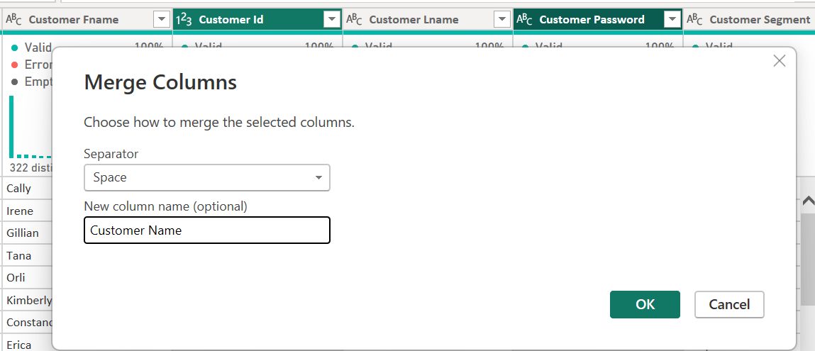
- Date/Time Datatype Correction
• Problem: `order date (DateOrders)` and `shipping date (DateOrders)` were imported as Text fields with time strings.
• Transformation: Applied `Change Type` to `DateTime`, then extracted `Date` for modeling.
• Reason: Enables proper date relationship linking and Time Intelligence DAX functions.
• Result: Fields converted to standard ISO `Date` data types.
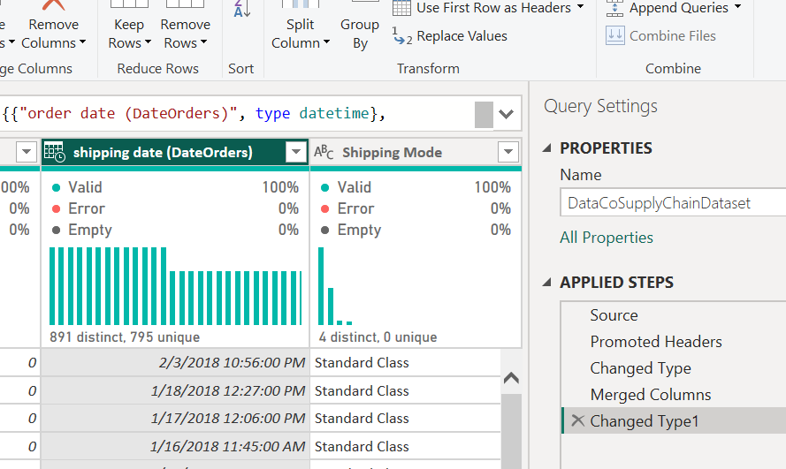
- Calculate Shipping Delay Gap (Custom Column)
• Problem: Raw data tracks real and scheduled shipping days separately without showing explicit delay variance.
• Transformation: Added Custom Column: `[Days for shipping (real)] - [Days for shipment (scheduled)]` named `Shipping Delay Days`.
• Reason: Quantifies exact delay duration per order for fulfillment analysis.
• Result: Numerical column with positive values (delays), zero (on-time), or negative (early).
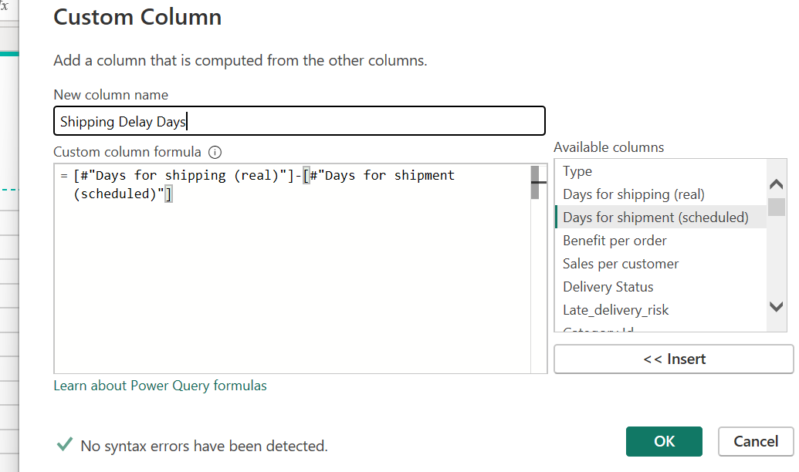
- Standardize Delivery Status Categories
• Problem: `Delivery Status` contained inconsistent values such as "SUSPECTED_FRAUD", "LATE_DELIVERY", "CANCELED".
• Transformation: Applied `Replace Values` and `Capitalize Each Word` to format as "Late Delivery", "Suspected Fraud", etc.
• Reason: Ensures visually appealing and consistent category labels in slicers and visuals.
• Result: Clean, human-readable text categories.
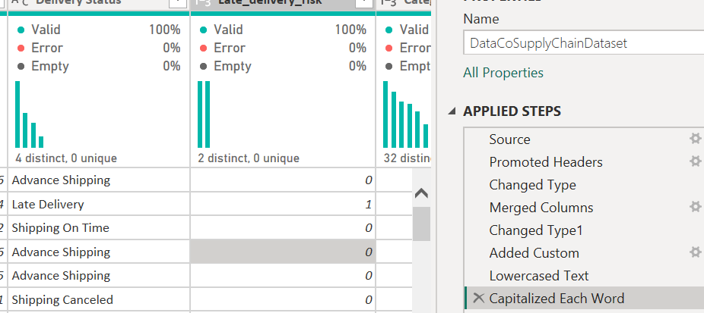
- Filtering Out Fraudulent Transactions
• Problem: Transactions flagged as `Suspected Fraud` skew fulfillment performance calculations.
• Transformation: Applied row filter on `Order Status` != "SUSPECTED_FRAUD".
• Reason: Prevents compromised/blocked orders from distorting operational shipping KPIs.
• Result: Dataset scoped strictly to valid commercial fulfillment records.
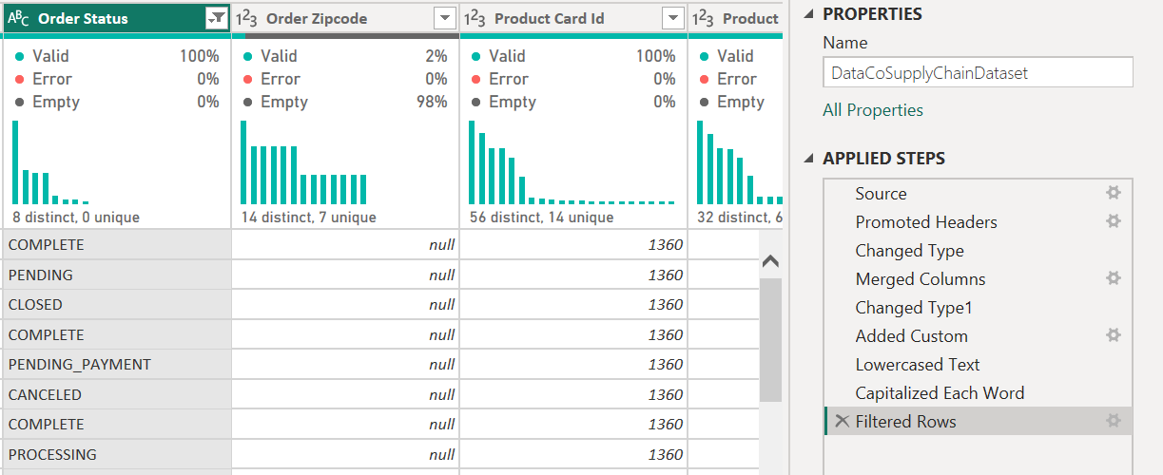
- Text Trimming & Cleaning
• Problem: `Market` and `Order Region` strings contained leading/trailing space whitespace.
• Transformation: Selected text dimension columns -> `Transform` -> `Text Column` -> `Trim`.
• Reason: Eliminates duplicate category groupings caused by hidden spaces.
• Result: Consistent, clean string values across all region dimensions.
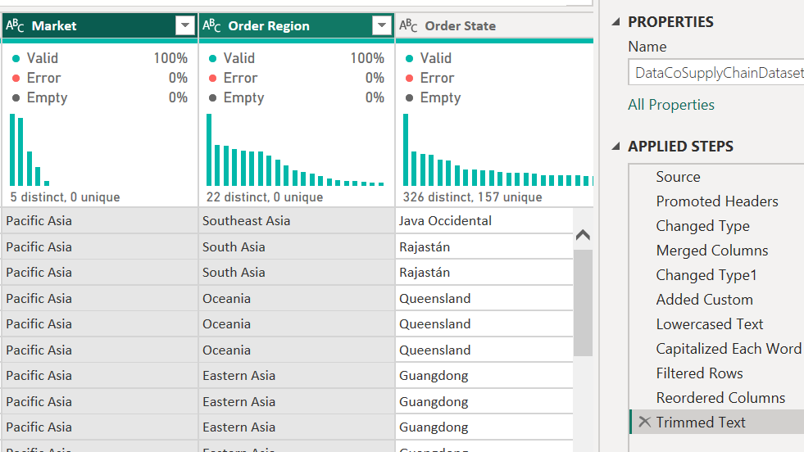
- Dimensional Table Creation (Reference & Deduplicate)
• Problem: Raw dataset is a single flat table containing customer, product, and location attributes mixed with measures.
• Transformation: Right-clicked source query -> `Reference` -> Kept `Customer Id`, `Customer Name`, `Customer Segment` -> `Remove Duplicates`.
• Reason: Extracts normalized dimension tables to build an optimized Star Schema.
• Result: Isolated `DimCustomer` table with unique `Customer Id` keys.
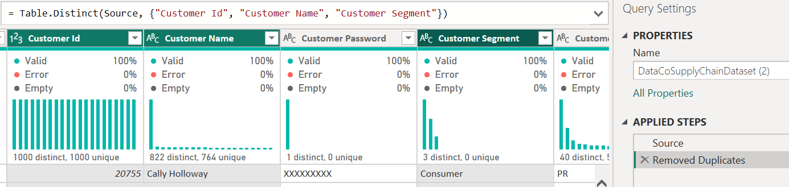
- Conditional Column for Late Risk Category
• Problem: `Late_delivery_risk` was stored as binary `1` and `0`.
• Transformation: Added Conditional Column: IF `Late_delivery_risk` = 1 THEN "High Risk" ELSE "Low/No Risk".
• Reason: Improves dashboard readability for non-technical stakeholders.
• Result: Descriptive categorical field `Delivery Risk Level`.
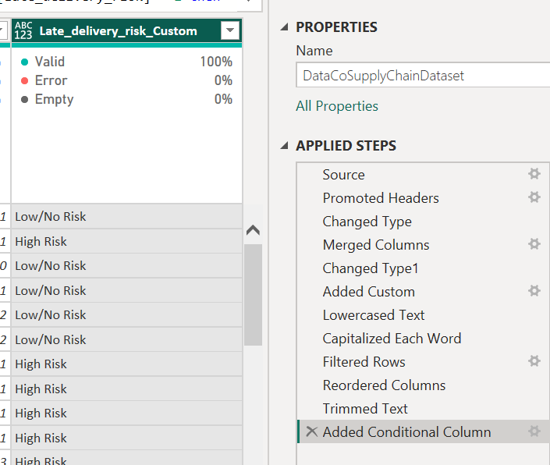

SECTION C: DATA MODELLING
Create DimCustomer
DimCustomer: Customer Id (PK), Customer Name, Customer Segment, Customer City, Customer Country.
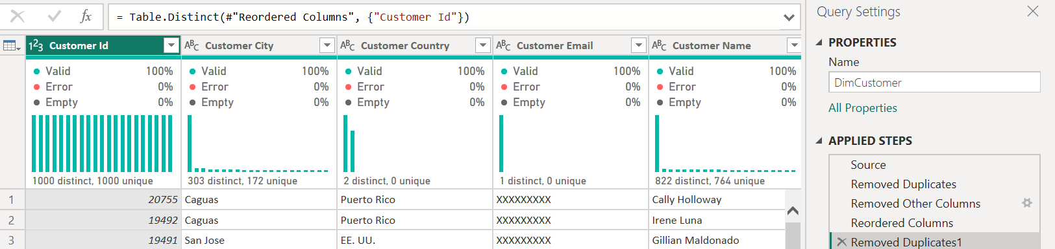
Create DimProduct
DimProduct: Product Card Id (PK), Product Name, Category Name, Department Name, Product Price.
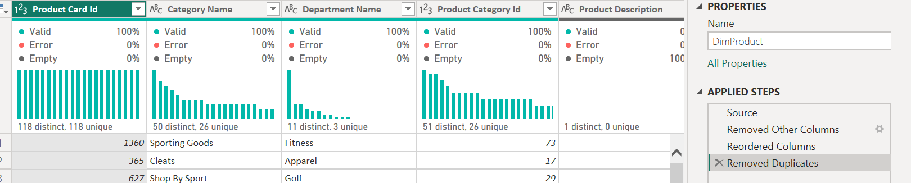
Create DimLocation
DimLocation: Location Id (PK), Market, Order Region, Order Country, Order City.
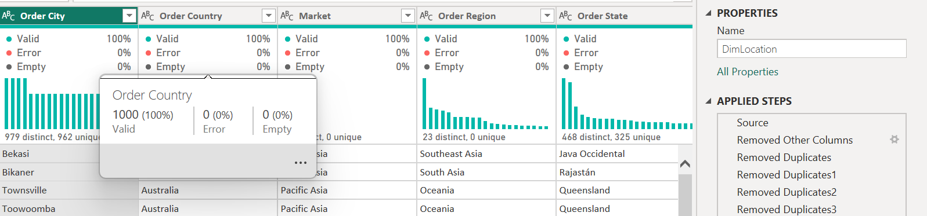
Create FactShipments
Fact Table (FactShipments): Contains keys (Order Id, Customer Id, Product Card Id, Location Id, Order Date) and numeric metrics (Sales, Order Profit Per Order, Shipping Delay Days, Order Item Quantity, Late_delivery_risk).
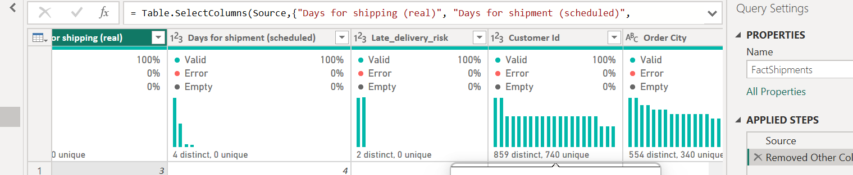
DimDate: Generated via DAX:
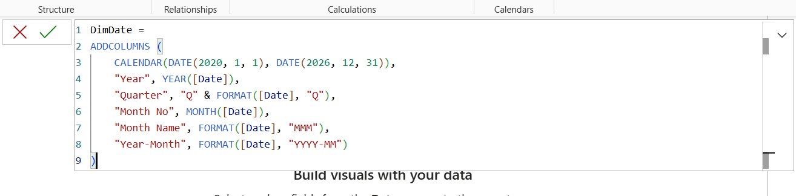
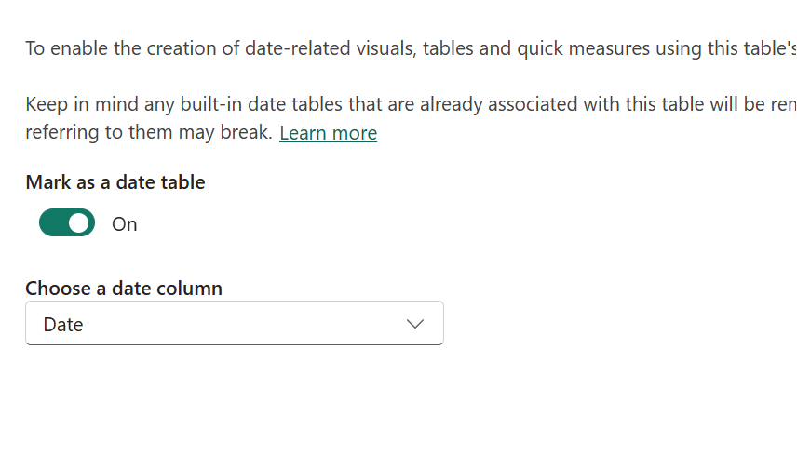
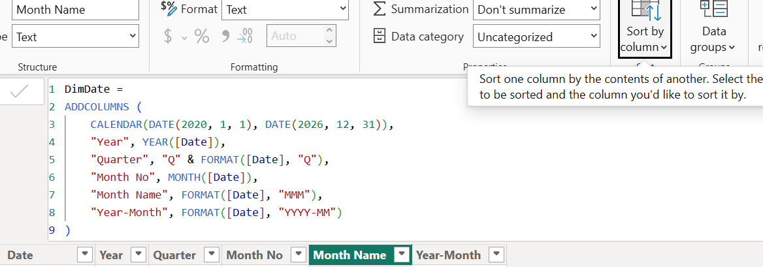
Create the Model Relationships (Model View)
DimCustomer[Customer Id] $→$ FactShipments[Customer Id]
- Cardinality: One to Many (1:*)
- Cross filter direction: Single
DimProduct[Product Card Id] $→$ FactShipments[Product Card Id]
- Cardinality: One to Many (1:*)
- Cross filter direction: Single
DimLocation[LocationKey] (or Region/Country keys) $→$ FactShipments
- Cardinality: One to Many (1:*)
- Cross filter direction: Single
DimDate[Date] $→$ FactShipments[Order Date]
- Cardinality: One to Many (1:*)
- Cross filter direction: Single

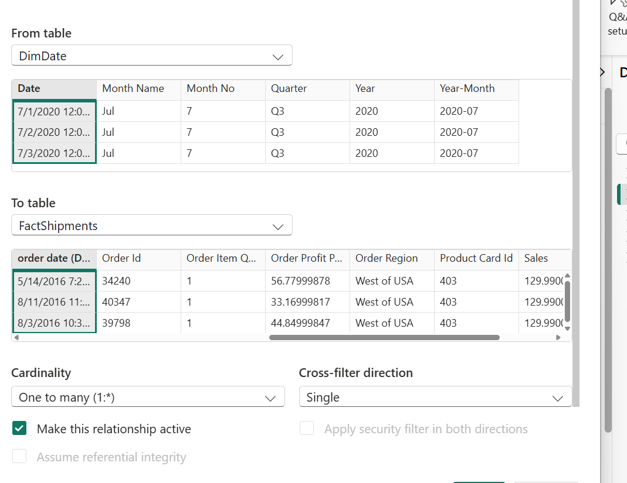
SECTION D: DAX & BUSINESS CALCULATIONS
-- 1. Total Revenue
Total Revenue = SUM(FactShipments[Sales])
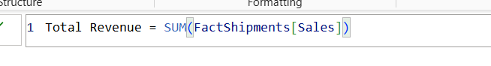
-- 2. Total Orders
Total Orders = DISTINCTCOUNT(FactShipments[Order Id])
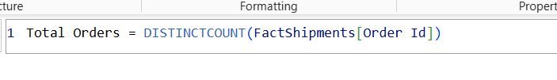
-- 3. Total Shipping Delays Count
Total Delayed Orders = CALCULATE(COUNTROWS(FactShipments), FactShipments[Late_delivery_risk] = 1)
-- 4. Average Real Shipping Days
Avg Shipping Days = AVERAGE(FactShipments[Days for shipping (real)])
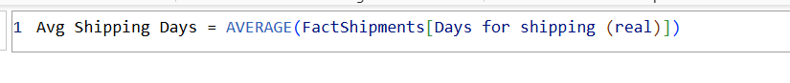
Level 2: Calculated Business Measures
-- 5. Total Profit
Total Profit = SUM(FactShipments[Order Profit Per Order])
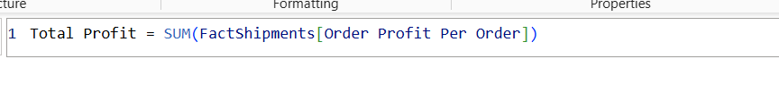
-- 6. Profit Margin %
Profit Margin % = DIVIDE([Total Profit], [Total Revenue], 0)
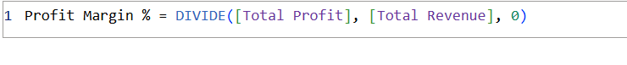
-- 7. On-Time Delivery Rate (OTDR %)
OTDR % =
DIVIDE(
[Total Orders] - [Total Delayed Orders],
[Total Orders],
0
)
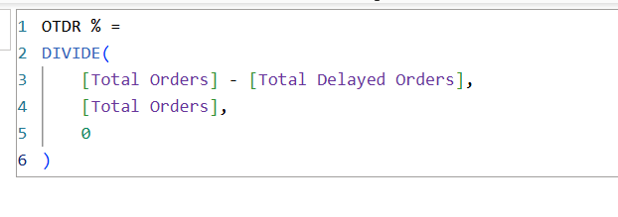

-- 8. Late Delivery Risk %
Late Delivery Risk % = DIVIDE([Total Delayed Orders], [Total Orders], 0)
Advanced DAX & Context Manipulation
-- 9. Previous Year Revenue (Time Intelligence)
PY Revenue = CALCULATE([Total Revenue], SAMEPERIODLASTYEAR(DimDate[Date]))
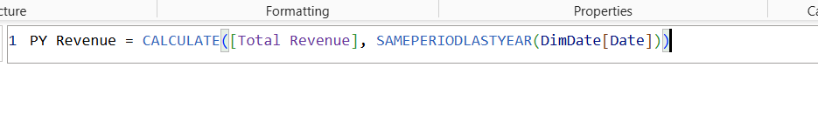
-- 10. YoY Revenue Growth %
YoY Revenue Growth % =
VAR CurrentRev = [Total Revenue]
VAR PrevRev = [PY Revenue]
RETURN
DIVIDE(CurrentRev - PrevRev, PrevRev, 0)
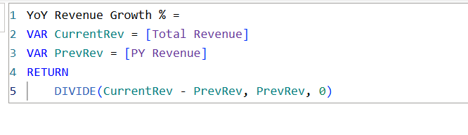
-- 11. Regional Freight Contribution % (Context Override using ALL)
% Revenue Share by Region =
DIVIDE(
[Total Revenue],
CALCULATE([Total Revenue], ALL(DimLocation[Order Region])),
0
)
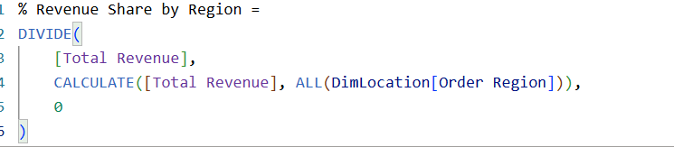
-- 12. Dynamic Logistics Performance Status (SWITCH/VAR Logic)
Logistics Health Status =
VAR RiskRate = [Late Delivery Risk %]
RETURN
SWITCH(
TRUE(),
RiskRate <= 0.15, "🟢 Optimal (<15% Risk)",
RiskRate <= 0.30, "🟡 Moderate Risk (15-30%)",
"🔴 Critical Risk (>30%)"
)
